**Name: Sanio Luke Sebastian**

**Roll No: 35**

**Batch: B**

**Date: 06-06-2022**

**NETWORKING & SYSTEM ADMINISTRATION LAB**

**Experiment No.: 15**

**Aim**

To study & know about the implementation of Wireshark and netcat tool.

**Procedure**

* **Wireshark**

Wireshark is the world’s foremost and widely-used network protocol analyser. It lets you see what’s happening on your network at a microscopic level and is standard across many commercial and non-profit enterprises, government agencies, and educational institutions. It is used for network troubleshooting, analysis, software and communications protocol development, and education.

For the installation and working of the Wireshark, follow the below commands.

1. **sudo apt-get update:** This command is used to update the software already installed with its latest version.

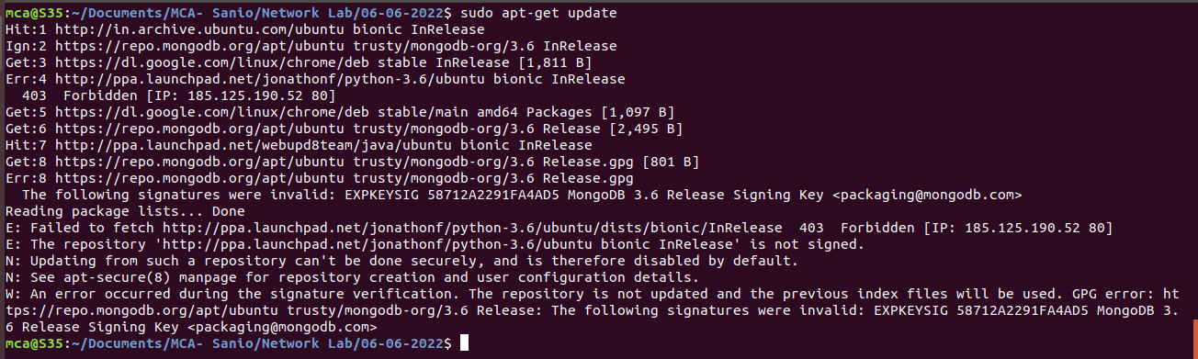

1. **sudo apt-get install wireshark:** This command is installs the wireshark tool/software into your software using the apt-get package handler tool.

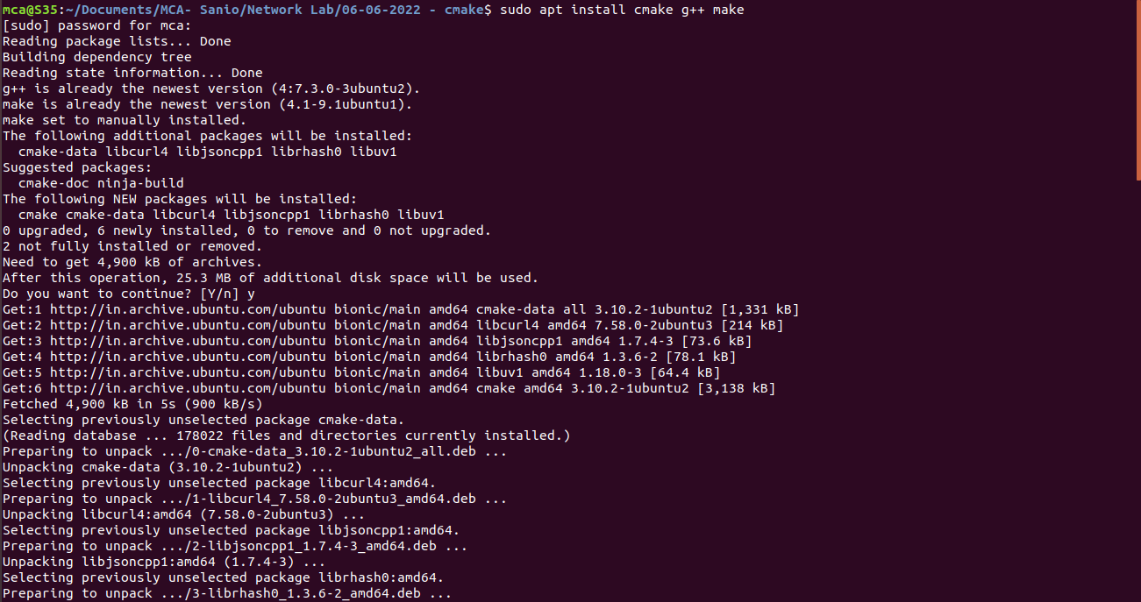

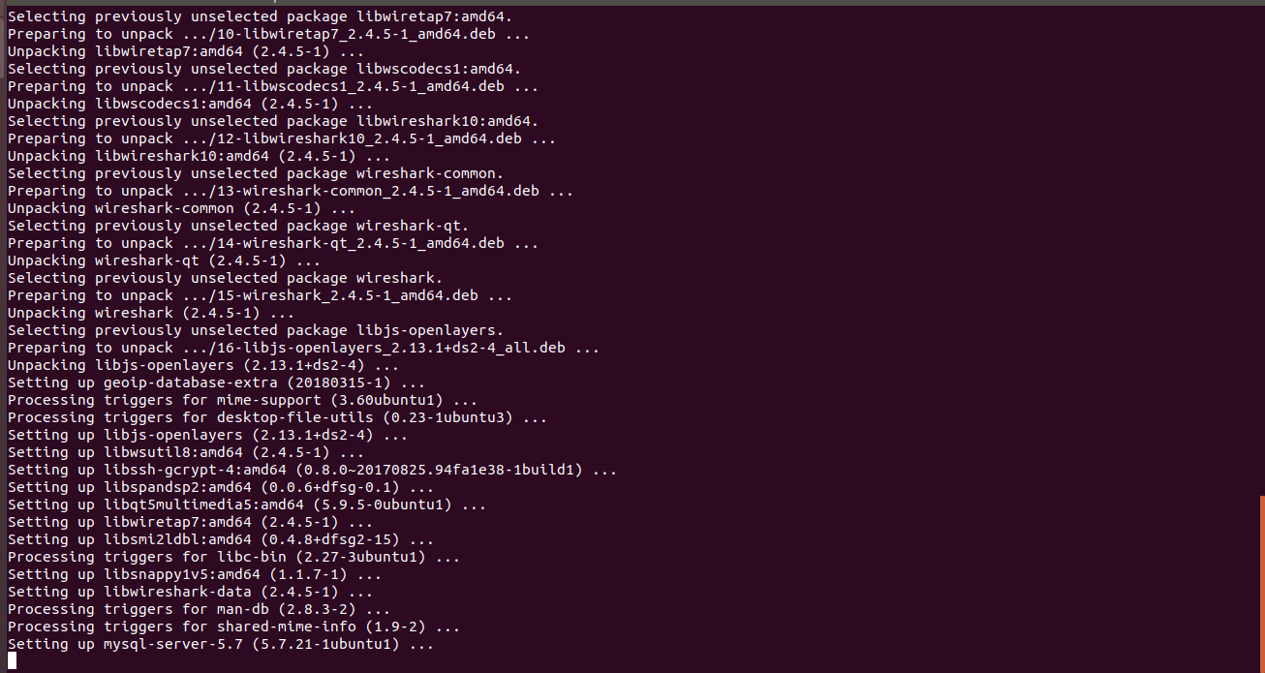

1. **sudo wireshark:** This command will open up the wireshark interface application.



Now, the below image shows the real traffic and packets transferring records and implementation in your active interface network.

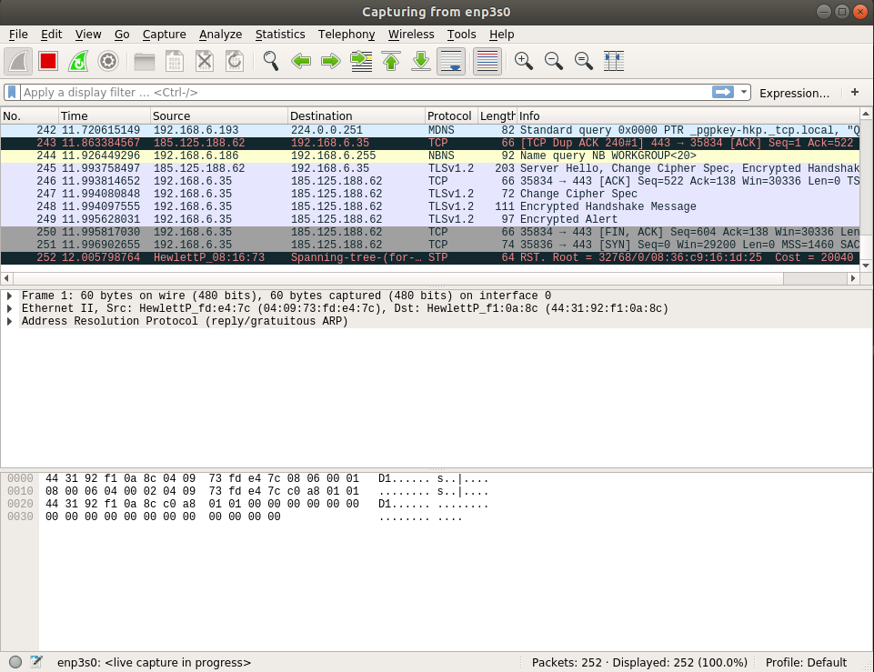

* **netcat**

Netcat or NC is a utility tool that uses TCP and UDP connections to read and write in a network. It can be used for both attacking and security. In the case of attacking. It helps us to debug the network along with investing it. It runs on all operating systems. Netcat functions as a back-end tool that allows for port scanning and port listening. In addition, you can actually transfer files directly through Netcat or use it as a backdoor into other networked systems.

For the installation and working of the Wireshark, follow the below commands.

1. **sudo apt-get install netcat:** This command allows you to install the netcat into your system using apt-get command line package handler tool.

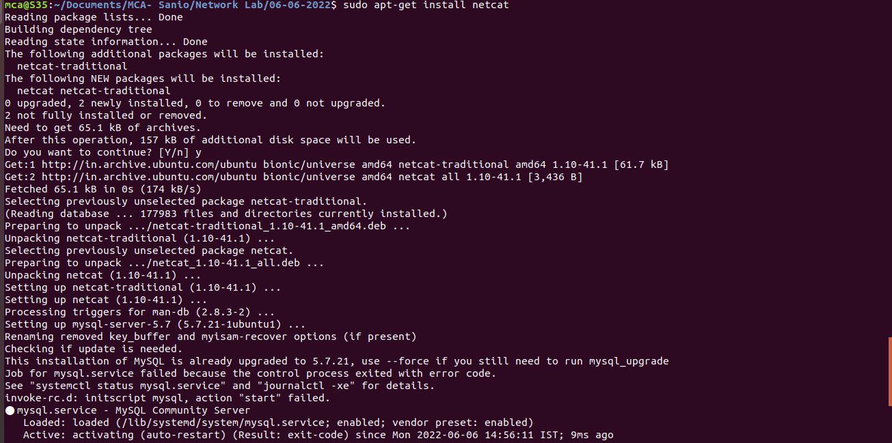

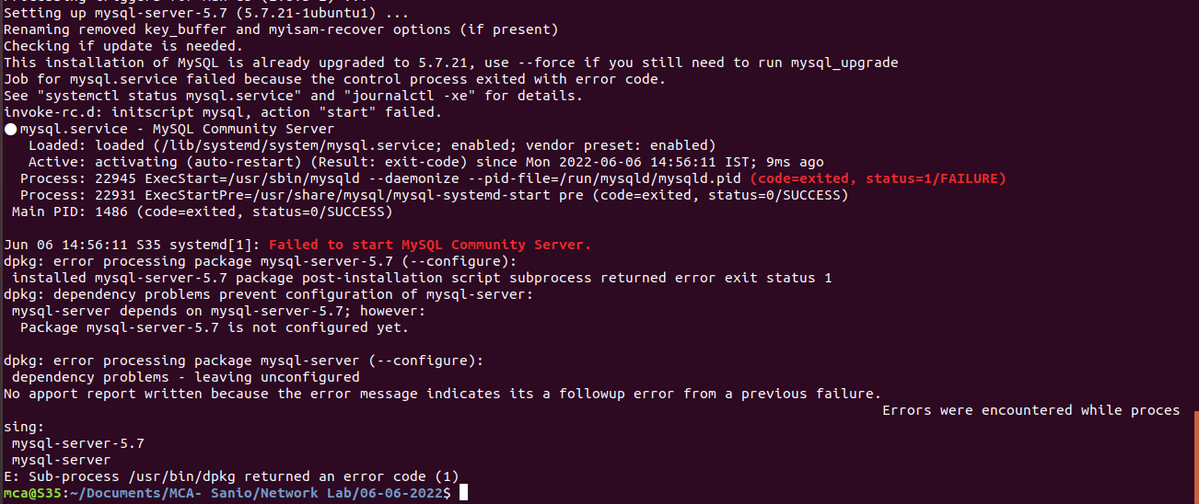

Now, we can connect within a network and communicate even between two terminals using unique names and IP address. The commands that follows to perform this are:

**From the side of listening terminal: $ nc -l -p 1234**

**From the side of requesting terminal: $ nc 127.0.0.1 1234**